System Block Diagram
Purpose
The block diagram shows the major inputs, processing block (FSM), and outputs of the traffic light controller.

Inputs
- clk - System clock
- rst - Active-high reset
- emergency_ns - Emergency request for North-South
- emergency_ew - Emergency request for East-West

Block Diagram
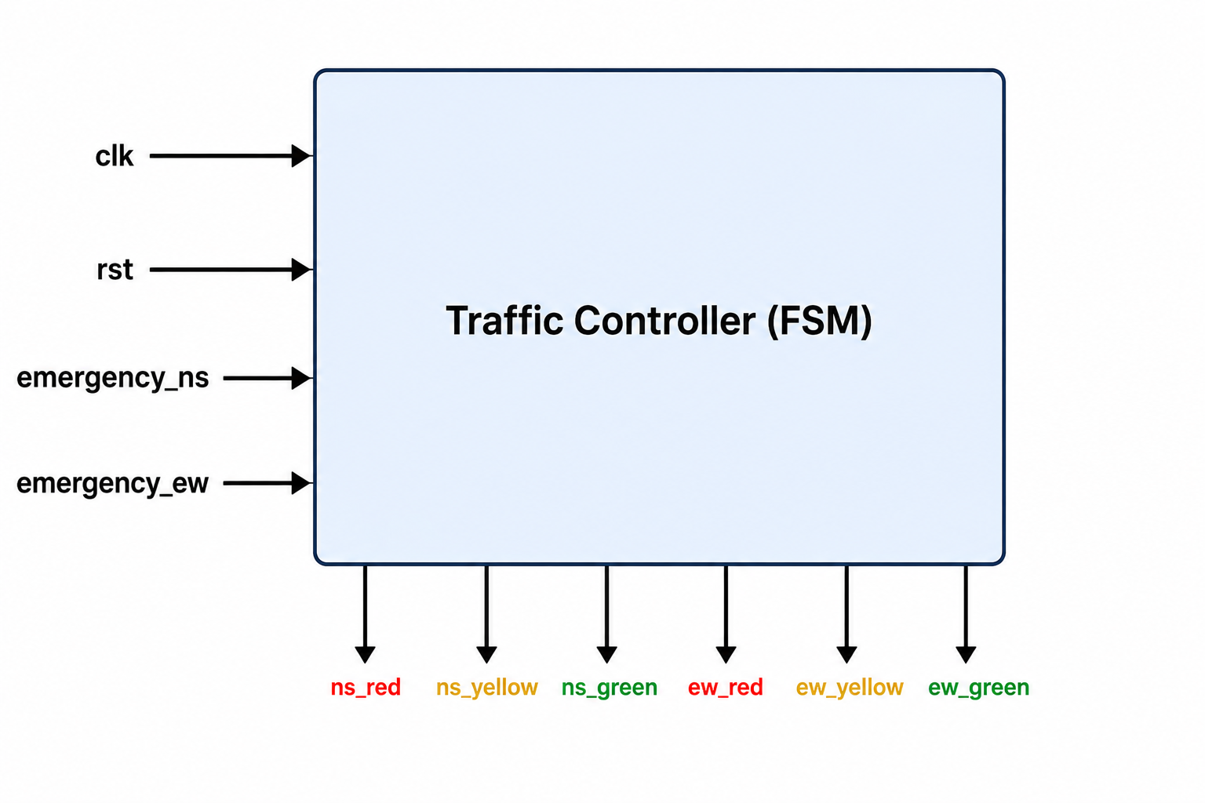

Block Description
Block | Function
Clock (clk) | Provides timing for the FSM.
Reset (rst) | Returns the controller to the initial state.
Emergency Inputs | Request priority for NS or EW direction.
Traffic Controller | Controls state transitions and light outputs.
Traffic Lights | Drive the Red, Yellow, and Green LEDs.

Design Flow
- Receive clock and reset signals.
- Check emergency inputs.
- Execute FSM state transition.
- Generate traffic light outputs.
- Repeat on every clock cycle.

